Fix gap streams notes
intro
Fix gap (fg) streams is a method for replacing sections of a course blue line stream network with sections of dem derived streams. The aim is to remove sections of blue line network where it is considered erroneous and that the dem will provide a more reliable location of the stream line. This can be considered a preprocessing step for stream enforcement into a DEM with software such as ANUDEM or it could be just for improving the blue line network.
Blue line improvement
If the aim is to improve on the blue line network that some smoothing of the new lines to remove the blockiness that comes from a dem generated stream might be desired. This should be done with care not to shift the end points of the stream or introduce new stream intersections. This step would not be required for input into a dem drainage enforcement process.
Which streams get modified
This is a subjective decision and requires an assessment of the characteristics of the locations where it is felt that the bluelines are not a good representation of the spatial position of the network in the dem. This is generally going to be steep hilly terrain where the dem can easily define the network location and mis location of the blue lines shows up clearly.
For the test case used in software development a range of elevation of greater then 20m in the 9 cell neighbourhood was used. Where one of those cells fell onto or next to a stream line this was expanded 10 dem cells up and downstream along the stream lines.
#python code
mask[dem_range > 20] = 1
expand_mask = scipy.ndimage.morphology.binary_dilation(mask,scipy.ndimage.generate_binary_structure(2, 2),10,stream_ras)
This rule is indicative of what could be used and should be subject to some analysis before use with different data in a different landscape.
The streams masked by this process become the ‘gaps’ that need to be ‘fixed’.
How it works
The method uses the dem to find a path through the network and around any ‘gaps’. The blue lines after the ‘gaps’ are removed is crudely enforced into the dem.
A d8 flow direction surface is created using a technique that will find a path out of any sinks (eg an enforced stream that meets a ‘gap’ that isn’t enforced) over the saddle that results in it having the lowest high point between the sink and the edge of the dem. Flat areas are carefully handles to produce aesthetically pleasing flow paths. The result of this processes is a d8 surface that is fully connected with all cells flowing to the edge of the dem. There is an option to have specified sinks remain.
A flow tracing type routine is then initiated from the very top pixel of all first order streams to define a fully connected network the flows according to the dem the best way past and gaps in the network. This includes any gaps in the original network not just those that were created in the earlier step.
The next steps involve extracting vector line work for just the sections of the flow tracing that go around gaps in the network and adjusting their ends so they meet the original blue line vectors correctly. The original vectors are then split at these locations.
At this stage we have a combined old and fixed network including the gaps and the fixes. The network is then analysed to provide some attribution. The lines to ‘keep’ and ‘discard’ are flagged and some metrics are calculated to help diagnosis of any issues.
X = 1 = keep
X = 0 = discard
Issues
The method doesn’t at this stage resolve all issues but aims to highlight anything that should be investigated. It is thought that a reasonable proportion of these could be handled with some simple rules automatically. Some of them would require some more coding effort but could be resolved. There may be others that are difficult to resolve the correct action automatically and are best deal with by manual intervention. At this stage the focus is on highlighting these issues for investigation and discussion before investing in more development time.
Dist = 9998 or 9997
This indicates that the new stream is joining 2 networks that previously didn’t join. These will be connectors through lakes and estuaries but also connect up stream that just end in the landscape. For fg streams use these can probably be discarded or better still trimmed to end at an appropriate locations. This trimming could possibly be automated. The connectors may be of further use for other needs.
Dist = 0 -1
This is an index that tells you how different the old and new path are. Each time we introduce a new path the distance down stream to where the old path meets the new path is analysed to produce this index. If the index is above about 0.15 then the path is quite different. Numbers closer to 1 have very very different paths. These should be investigated. These usually happen when the top of a first order blue line is ,according to the dem, in a different streams catchment to the rest of that blue line network. Many of these could be fixed by not using the very top bit of the first order streams.
Dist = 9999 = not flagging anything = ignore this value
Keep_dist = 0 – 1
This is similar to dist but is a ratio of the distance of stream kept along the old and new path. IT should be around 50% if it is very high then you have some parallel stream paths going on. This sometimes happens due to some ambiguity in the way the enforced flow paths are used. This is generally a method issue which i have yet to resolve.
Cycle_locations and out_streams_diag
The main issue with the technique used is that when a gap is introduced int he stream network the method has to find a path around that gap over a saddle. Sometimes the lowest suitable saddle is in a very different location. This results in the flow tracing code preferentially flowing the wrong way up the network to the lower saddle. This introduces an issue because we keep only the new streams that are away from the original network these flow in a different direction to what is expected and we end up with a conflict in the network that shows up as the new stream and the old stream it was replacing being in a cycle.
This is problematic for further processing so at this stage stream segments around the cycle are removed.
A file showing the point where this removal takes place is created and a full set of streams is created before this removal to assist in diagnosing this problem
Bugs
There are still some bugs with the method – most just need a bit of time to fix.
- When gaps are large multiple streams might join together when getting pass the gap. These joins arnt handled and you end up with multiple streams stacked on top of each other.

Results
Flow paths through a flat area – it does a good job of connectors in estuaries
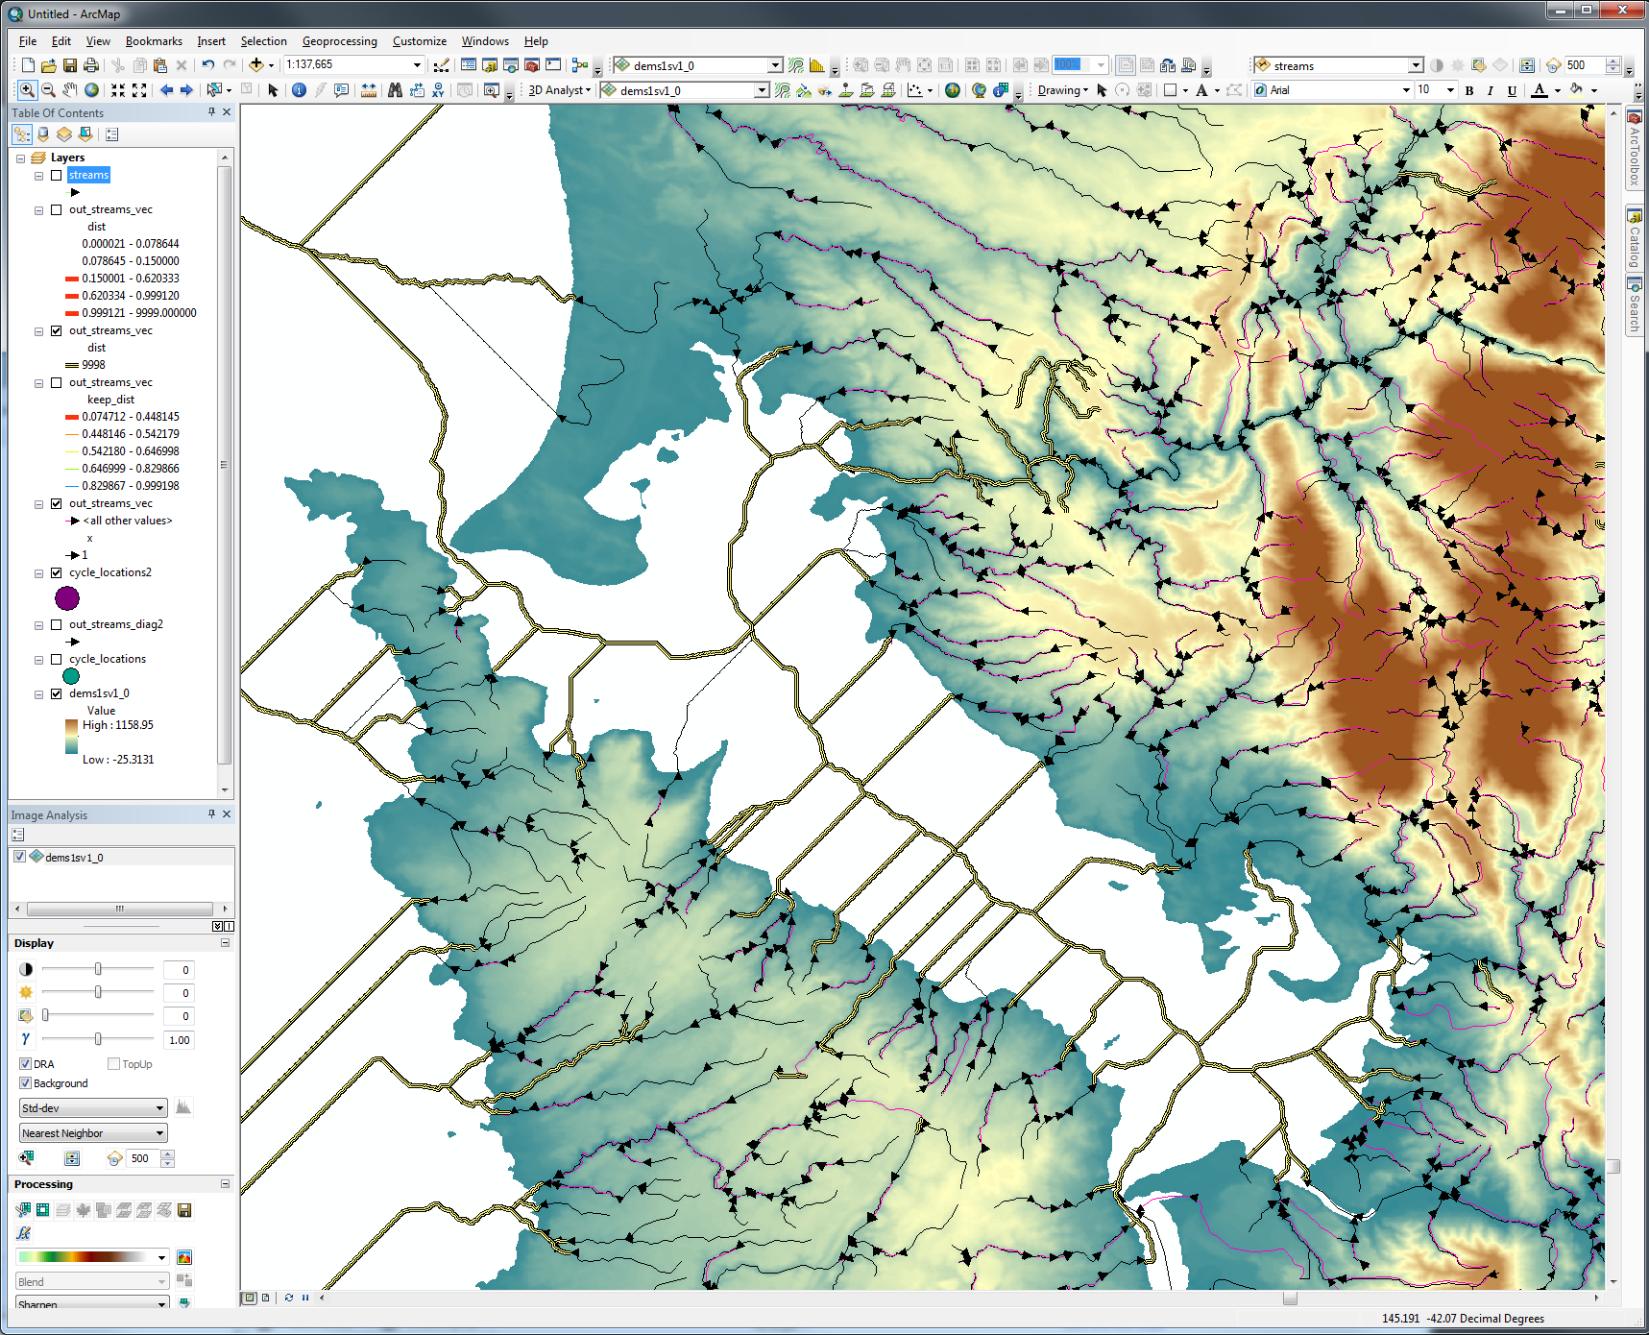

Loops highlighted for dealing with
